## MultiMedia field

### Summary

The MultiMedia field is the extension of image field. It has become possible now to insert and view multimedia content in image fields.

Supported multimedia formats:

1. Flash objects: *swf*-files,
2. Flash video: *flv*-files,
3. Windows Media video: *wmv*-files,
4. Windows Media Player video: *avi*-, mpeg-, asf-files,
5. QuickTime video: *mov*-, *qt*-files,
6. Real video: *rm*-files,
7. Audio: *mp3*-, *wma*-, ogg-files

MultiMedia field is easy configurable and extensible.

### Requirements.

To play multimedia content user has to have the corresponding plug-in installed:

1. Adobe Flash Player: <http://www.adobe.com/products/flashplayer/> ,
2. Microsoft Silverlight: <http://www.microsoft.com/silverlight/get-started/install/default.aspx> ,
3. Microsoft Windows Media Player: <http://www.microsoft.com/windows/windowsmedia/download/AllDownloads.aspx?displang=en> ,
4. Apple QuickTime: <http://www.apple.com/quicktime/download/> ,
5. RealPlayer: <http://uk.real.com/realplayer/>

### Inserting multimedia content

To insert a multimedia content in the image spot:

1. Make sure the page is in the editing mode.
2. Move the mouse over the image where you want to add a multimedia object, till you see a frame with buttons below.

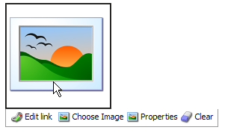

1. Click the Choose Image button. A dialog window appears.

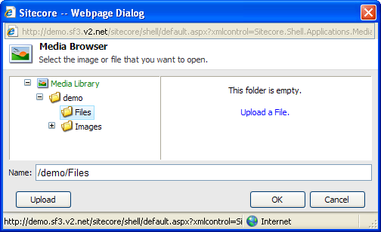

1. Click the required multimedia object in the folder tree of the Media Library.
2. Click the OK button. The multimedia object is inserted.

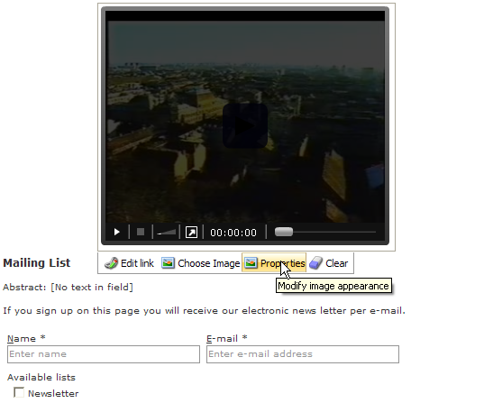

As you can see from the picture, the width and height of video files can also be edited in the Properties option.

